Graph Theory

Directed Graph:

Where every EDGE has direction and the mapped vertices

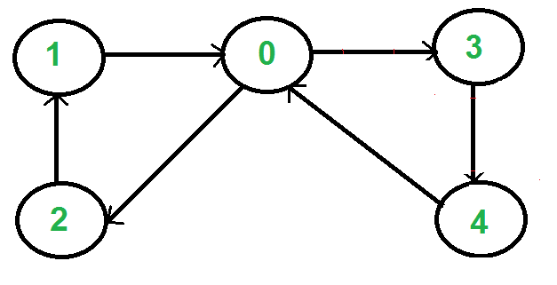

Undirected Graph:

Where there wont be an arrow to point to any direction for the edge

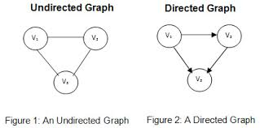

Adjacent vertices:

Any vertices that are connected with the edges then they are called adjacent vertices

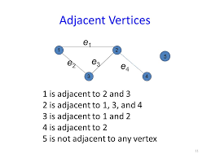

Self loop:

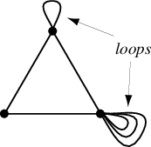

Simple Graph: Graph that does not have loop or parallel edge

General Graph(Multi graph): which has either loop or parallel edge or both

Complete Graph:

There consists of an edge between every pair of vertices then that graph is called complete graph

Weighted Graph:

Let G(V,E) be any graph and W:E->R be a function from set E to set real number R. Then Graph G(V,E,W) in each edge is assigned a number called weight of the edge , is known as weighted graph

Finite Graph:

Graph in which the vertices are finite

Infinite graph: Graph in which the vertices are infinite

Trivial Graph:

A graph in which there is one node but no edges

Null Graph: No edge and no vertices

Terms in a graph:

Edge , Vertex ,

Order of the graph: No. of vertices in the graph;

Degree in a graph:

* It is a value that is present in a vertex.
* In degree (d+) : No of edges that are coming towards the vertex
* out degree(d-): No. of edges that are going out from the vertex

First Theorem in Graph Theory:

* The Sum of degrees of all the vertices in a graph G is equal to twice the number of edges in G

Regular Graph:

* A Graph in which the degree of all the vertex is same
* If the degree is K for all the vertex, then it is called K-Regular Graph

Chapter 2:

ISOMORPHIC GRAPHS:

* Same Number of Vertices
* Same number of edges
* Equal number of vertices with given degrees
* One-One correspondence to Edges and Vertices

Sources:

<https://github.com/mrdbourke/pytorch-deep-learning>

<https://www.youtube.com/watch?v=Z_ikDlimN6A>